1940223_paired_ttest–3-.R

pranav

2020-09-18

QUESTION 3

data = c(116, 111, 101, 120, 99, 94, 106, 115, 107, 101, 110, 92)

Here, we have a sample of IQ test results for a group of people given fish oil supplement for one year. Since there is only one sample, we do a one sample t-test.

#

AIM

#

We need to find out if the mean of the population of people given the fish oil supplement for one year would equal 100.

CHECKING ASSUMPTIONS

#

Assumption 1…

#  
shapiro.test(data)

##   
## Shapiro-Wilk normality test  
##   
## data: data  
## W = 0.96995, p-value = 0.9103

We see that p = 0.9103> 0.05, hence the sample can be said to be taken from a normal distribution.

#

Assumption 2…

#

Since the IQ results of one person are not affected by the IQ results of other people (we assume there is no malpractice), the samples are drawn independently.

#

Assumption 3…

#  
boxplot(data, xlab = "IQ results")

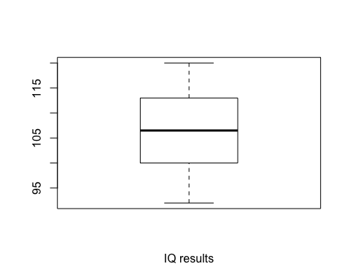

No outliers.

#

ONE SAMPLE T-TEST

#  
t.test(data, mu = 100)

##   
## One Sample t-test  
##   
## data: data  
## t = 2.3534, df = 11, p-value = 0.03826  
## alternative hypothesis: true mean is not equal to 100  
## 95 percent confidence interval:  
## 100.3886 111.6114  
## sample estimates:  
## mean of x   
## 106

Here we see that p = 0.03826 < 0.05, hence we cannot say that the sample’s population’s mean is not 100. Furthermore, the 95% confidence interval of the population mean is (100.3886, 111.6114), which does not contain 100.